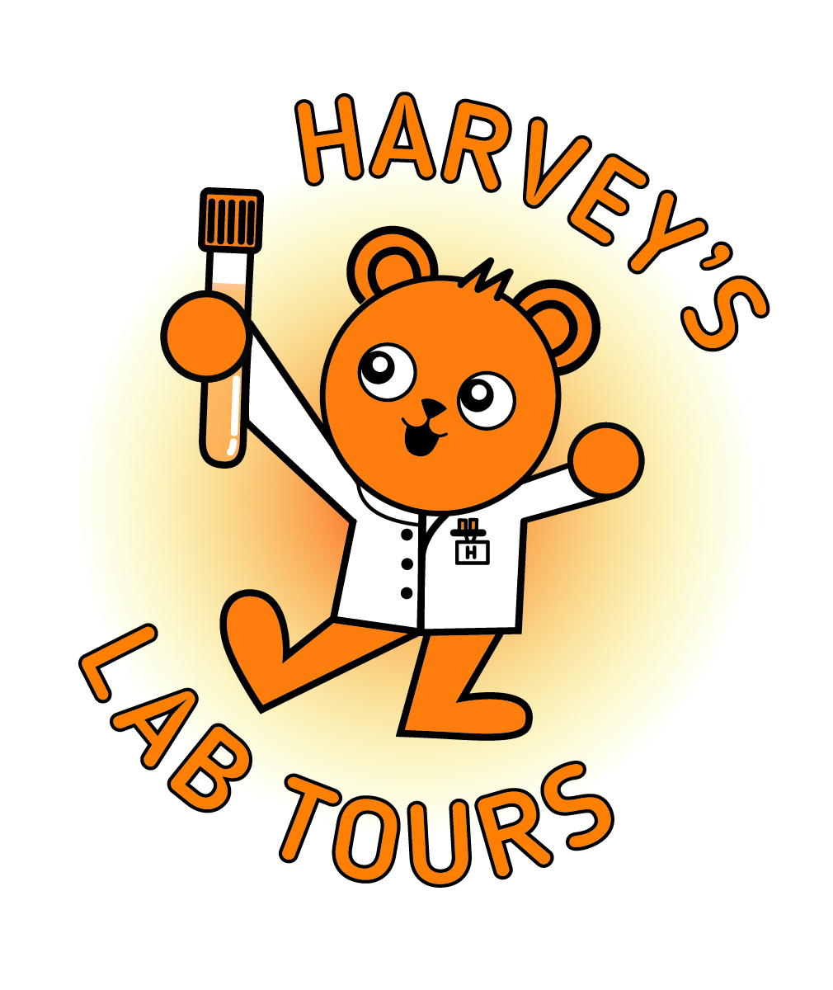

Harvey’s Lab Tours: Risk assessment guidance and example content
Preparing to run tours can feel daunting, but you don’t need to start from scratch. This document is designed to support you in developing a local risk assessment for Harvey’s Lab Tours that reflects your laboratory, your staff and the activities you choose to run.
The guidance and templates provided are intended as a starting point. They highlight common considerations such as visitor suitability, infection control, confidentiality, supervision, equipment use and emergency procedures. Not every point will be relevant to every site, and you may need to add local controls or remove elements that don’t apply.
Risk assessments should always follow your local policies and governance processes.

Content | Page number(s)
1. Common areas to consider when creating a risk assessment | 3–5
2. Example risk assessment (template content) | 6–11
3. Safeguarding and inclusion | 11
4. First aid and emergencies | 11
5. Tips for creating your own risk assessments | 12

1) Common areas to consider when creating a risk assessment
Use the table below to prompt what you may need to include in your local risk assessment. Adapt the risks and controls to match your environment, route and demonstrations.
Area | Risks to consider | Controls
1. People attending | - Vulnerable visitors (including immunocompromised)  - Varied ages  - Disability and additional needs: physical, cognitive (incl. SEND), communication, sensory  - Insufficient supervision  - Visitors straying into restricted areas | - Confirm no immunocompromised patients will enter the lab (or postpone/adjust as per local policy)  - Keep groups small (ideally one tour at a time; max 2 young patients and their families, max of xx people on the tour)  - Send a short pre-tour questionnaire to the guardian/young patient to identify support needs  - Continuous supervision by trained lab staff; “stay with your guide” rule  - Defined route; keep non-tour doors/areas closed
2. Infection prevention and control | - Contact with contaminated surfaces/equipment  - Poor hand hygiene / touching face  - Shared props (microscope/pipettes/pods) | - PPE as per local policy  - Short safety brief on entry: what to touch / what not to touch  - Hand hygiene encouraged; point out facilities on arrival  - Decontaminate kit before use and wipe shared touchpoints as needed  - No patient samples with identifying information will be handled or shown, apart from those belonging to the patient attending the tour.
3. Slips, trips and falls | - Cluttered walkways, bags, cables, wet floors  - Distraction during demonstrations  - Increased risk for those with mobility issues | - Route check immediately before the tour; remove trip hazards  - Keep walkways clear; bags/coats stored in a designated spot  - Replace full bins (including sharps bins) before the visit where possible  - Keep pace slow; stop only in clear, safe areas
4. Mobility and evacuation (fire) | - Difficulty moving around the lab or evacuating quickly  - Visitors not accounted for during an evacuation | - Confirm mobility needs in advance; plan an accessible route (including lift access where relevant)  - Signing tour attendees into the Lab  - Fire brief at the start: exit routes and assembly point  - Point out toilets, handwashing, eyewash and PPE points  - Record visitors on the Daily Huddle sheet (or local fire register)
5. Confidentiality / information governance | - Patient identifiers visible on screens/paperwork/labels  - Overhearing sensitive information  - Photos/recording | - Confidentiality reminder at the start  - Plan route to avoid identifiable information where possible  - Use training/EQA slides only for microscope viewing (no patient identifiers)  - No patient samples with identifying information will be handled or shown, apart from those belonging to the patient attending the tour.  - Photos and filming permissions clearly explained.
6. Spillages | - Coloured water/saline spills (slip hazard)  - Clean-up disrupts lab work | - Use small volumes; contain liquids (tray/mat if available)  - Demonstrate first; visitors carry out activities under supervison  - Spill kit accessible; staff know local clean-up process  - If a spill occurs: stop activity, keep group back, clean per procedure
7. Misuse/breakage of demo kit | - Dropped slides; damaged equipment  - Pipette set incorrectly causing leaks/breakage  - Visitors touching items they shouldn’t | - Use a prepared “teaching” bench away from clinical work  - Pipette volume changes done by trained staff only  - “Hands off unless invited” rule  - Use robust, non-critical training kit where possible
8. Pneumatic tube demonstration | - Pinch points / trapped fingers  - Confusion with live sample transport  - Interference with operational use | - Demo pods only (no real samples)  - Young patients supervised at all times  - Visitors stand back; explain before operating  - Choose a time/location that minimises disruption
9. Protecting patient testing and turnaround times | - Group blocks access to analysers/benches  - Interruptions delay urgent work/results | - Agree on suitable tour; notify the team in advance  - Clinical work takes priority (pause/redirect if needed)  - Route avoids high-traffic/critical zones  - Assign a lead guide for each section of the tour
10.Chemicals/reagents in stores/fridges | - Visitors opening fridges/stores or accessing reagents  - Accidental exposure | - No access to chemicals/reagents; keep stores/fridges closed (locked where possible)  - Avoid routes past chemical storage  - If discussed, explain verbally - do not open storage
11. Activities undertaken during the tour (all demonstrations / hands-on elements) | Confusion about what can/can’t be touched  - Activity not suitable for age/ability/additional needs  - Encroaching on live clinical work / restricted areas  - Poor hand hygiene / shared touchpoints  - Breakage or misuse of demo kit  - Congestion / trip hazards when stopping  - Confidentiality risks if near live workstations | - Explain each activity before starting; staff demonstrate first  - Adapt/omit activities based on pre-tour questionnaire;  - defined stopping points  - Infection control/PPE - wipe shared items between users  - Staff control settings (e.g. pipette volumes);  - Keep group small and supervised; keep activities short; stop/modify activity if safety or workflow is impacted  - Avoid identifiable info; use training/EQA slides only; confidentiality reminder at start

2) Example risk assessment
Risk Assessment and Method Statement (RAMS)
Section | Details
Activity | Harvey’s Lab Tour – laboratory tour and demonstration activities
Location | Laboratory (tour route and designated demonstration points)
Method (how it’s delivered) | Supervised guided tour for young patient(s) with carer(s)/staff, with controlled demonstrations/activities
Staffing and group control | - Small groups only  - Visitors escorted at all times by Biomedical Scientists/laboratory staff
General control rules (apply to all activities) | - No immunocompromised patients enter the lab (or postpone/adjust as per local policy)  - PPE and hand hygiene as per local policy  - No patient samples with identifying information handled or shown, apart from those belonging to the patient attending the tour.  - Supervision of equipment when activities carried out  - Equipment/touchpoints decontaminated as needed  - Fire brief delivered; visitors recorded for evacuation accountability (Daily Huddle sheet/local process)  - No access to storage areas

Guided lab tour (moving through the lab) – risk assessment
Hazard | Persons at risk | Potential harm | Control measures | Residual risk
Infection exposure | - Visitors  - Staff | Infection transmission | - PPE as per local policy  - Hand hygiene  - No patient samples used/accessed  - Planned touchpoints decontaminated  - Visitors stay with guide | Low
Slips/trips/falls | - Visitors  - Staff | Injury from falls | - Pre-tour route check  - Clear walkways  - Manage bags/coats  - Controlled pace  - Stop only in clear areas | Low
Restricted areas / wandering | - Visitors  - Staff | Injury; security breach | - Defined route  - Doors closed  - Continuous supervision  - Small groups | Low
Distress/challenging behaviour | - Visitors  - Staff | Injury; disruption | - Pre-brief (what to expect and rules)  - Carers responsible for children  - Identify quick exit/quiet space  - Stop tour if unsafe | Low
Fire / evacuation | - Visitors  - Staff | Harm during evacuation | - Fire brief at the start  - Keep group together  - Visitors recorded (Daily Huddle sheet/local register) | Low
Confidentiality / Patient data | - Visitors  - Patients (indirect) | Data breach | - Avoid identifiable screens/paperwork  - Confidentiality reminder  - No photos/filming where policy applies | Low

Activity risk assessment examples
Use or adapt the examples below for specific activities you may include in your tour.
Pneumatic tube pod demonstration (send/receive)
Hazard | Persons at risk | Potential harm | Control measures | Residual risk
Pinch/trap points | Visitors; staff | Finger injury | Mark safe standing point; “hands off”; BMS operates the station only; explain before operating | Low
Confusion with live sample transport | Lab service; patients (indirect) | Interference; delays | Demo pod only; quiet time/location; stop if clinical priority arises | Low
Infection via shared pod/touchpoints | Visitors | Infection transmission | Wipe pod/contact points before/after; hand hygiene | Low

“Fake sample” loading to analyzer / showing loading positions (RSA demo)
Hazard | Persons at risk | Potential harm | Control measures | Residual risk
Moving parts / pinch points | Children; visitors | Minor injury | Safe line/position; BMS loads/unloads only; no reaching into analyser | Low
Interference with patient testing | Lab service; patients (indirect) | Delayed testing/results | Demonstrate only when appropriate; keep brief; pause/stop if clinical work needed | Low
Confidentiality (screens/labels) | Visitors; patients (indirect) | Data breach | Position group away from identifiers; tidy/cover paperwork; training screens/materials where possible | Low
Infection control | Visitors; staff | Infection transmission | No patient samples; decontaminate touchpoints; hand hygiene; PPE | Low
Equipment damage | Lab service | Disruption/cost | Visitors do not touch analyser; BMS controls all handling | Low

Microscope viewing (training/EQA slides)
Hazard | Persons at risk | Potential harm | Control measures | Residual risk
Glass/slide breakage | Children; visitors | Cuts/minor injury | Training/EQA slides only; BMS positions/removes; young patientsdo not handle slides | Low
Infection via shared touchpoints | Visitors | Infection transmission | Wipe eyepieces/controls between users as needed; hand hygiene; PPE | Low
Confidentiality | Visitors; patients (indirect) | Data breach | Training/EQA only; keep patient paperwork out of view | Low
Crowding at bench / trip risk | Visitors | Falls/injury | One child at a time; manage queue; keep walkway clear; no stools unless essential and supervised | Low

Pipetting demonstration (coloured water/saline “colour change”)
Hazard | Persons at risk | Potential harm | Control measures | Residual risk
Spillages | Visitors; staff | Slips/falls; disruption | Small volumes; tray/mat; stop and clean per procedure; reassess floor safety | Low
Pipette misuse / breakage | Visitors | Minor injury; kit damage | BMS sets volume; child only does simple action if appropriate; robust/training pipette where available | Low
Contact with eyes/mouth | Children | Minor harm | Coloured water/saline only; no mouth pipetting; hands away from face; hand hygiene after | Low
Infection via shared kit | Visitors | Infection transmission | Wipe touchpoints as needed; hand hygiene; PPE | Low

Hazards applicable across all activities
Hazard | Persons at risk | Potential harm | Control measures | Residual risk
Unsuitable attendees (e.g., immunocompromised) | Visitors | Increased infection risk | Confirm no immunocompromised visitors enter; postpone if needed; small groups | Low
Access to chemicals/reagents/fridges/stores | Visitors | Exposure to hazardous substances | No access; keep closed/locked where possible; avoid routes past storage; discuss verbally without opening | Low
Obstruction/delay to patient work | Lab staff; patients (indirect) | Delays to testing/results | Agree timing; clinical work priority; avoid critical zones; lead guide manages questions | Low
Manual handling (set-up) | Staff | Strains/injury | Set up in advance; avoid heavy moves during tour; trolleys; two-person lifts | Low
Allergies/sensitivities | Visitors; staff | Irritation/reaction | Latex-free PPE where possible; minimise strong cleaning products; offer alternatives if required | Low
Electrical/thermal/noise | Visitors | Shock/burn/distress | Cable management; “do not touch”; avoid hot zones; warn alarms may occur; allow opt-out | Low

Safeguarding and inclusion
Tours are supervised at all times and group size is controlled to maintain safe oversight of young patients and carers.
We will work with young patients with any additional needs to ensure they are supported to take part, including physical, sensory, communication, cognitive, mental health and emotional needs. Where appropriate, requirements will be discussed in advance with the patient and/or carer to agree a suitable route, pace, demonstrations and control measures.
First aid and emergencies
The tour lead briefs fire routes and procedures at the start and ensures visitors are recorded for evacuation accountability (Daily Huddle sheet / local process). First aid arrangements and escalation contacts should be confirmed before the tour begins.
Contacts
Tour Lead: __________________________
Department Manager: __________________________ Date: _______________________________

3) Tips for creating your own risk assessments
- Be clear on what you’re assessing: activity, location, who leads it, and what’s included/excluded.
- Think about people first: visitors, staff, indirect impacts (patients/service), and additional needs.
- Walk the route: note pinch points, bottlenecks, restricted doors, noise/alarms, wet floors and where people gather.
- Assess the activities you will be carrying out
- Write hazards in specific terms: name the actual risk (e.g., trips from trailing cables; identifiers visible on screens).
- Make controls practical and checkable: route defined, group size limits, supervision, safe standing points, cleaning steps.
- Use the hierarchy of control: avoid/substitute where possible; then physical controls, procedures, and PPE.
- Include pause/stop triggers: clinical priorities, visitor distress, spill, equipment alarms—plus who makes the call.
- Cover the commonly missed areas: confidentiality/IG, infection prevention and control, safeguarding, operational impact.
- Keep it aligned with local policy: use local risk scoring and IPC/fire/IG/safeguarding requirements.
- Review and update: after the first tours, annually, and whenever anything changes (route, kit, staffing, policy).

