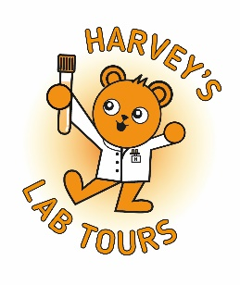
Harvey’s Lab Tour – Reflection questions for sites post-tour
This reflection form is intended to support staff who deliver Harvey’s Lab Tours in reviewing each visit once it has taken place. It provides a simple way for tour leads and participating staff to note what worked well, consider any challenges encountered, and identify any improvements for future tours.
Completing this reflection helps ensure that each visit remains safe, well organised and engaging for young patients and their families, while supporting continuous improvement.

Harvey’s Lab Tour – Reflection questions for sites post-tour

Date: _________________________________________________

Site/Lab: ______________________________________________

Tour lead: _____________________________________________
Staff involved: ______________________________________________________________________

Group size (patient + family): ______________________________________________________
Tour type / focus (e.g. haematology, microbiology):________________________________

What worked best on this tour?

What did the young patient/family respond to most positively?

What could be improved?

What didn’t go as planned (if anything)?

One change you’d make next time:

Safety, IPC and confidentiality
Any issues or near misses? ☐ No ☐ Yes (brief details):

Do any policies, SOPs, or risk assessments need updating because of this tour?
☐ No ☐ Yes (what and why):

Actions for next time

