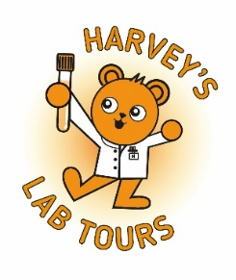
Harvey’s Lab Tours - Press release template

This template is provided to help laboratories and organisations share news about their involvement in Harvey’s Lab Tours. It can be adapted to highlight local activity, explain the purpose of the tours and showcase the role of biomedical scientists in supporting young patients and their families. Sites are encouraged to tailor the text with their own details, quotes and examples while ensuring any images or patient stories used have the appropriate consent in place.

Harvey’s Lab Tours - Press release template

[Insert hospital/laboratory name] supports young patients through Harvey’s Lab Tours
[Insert date] – [Insert name of your organisation or hospital laboratory] is proud to support Harvey’s Lab Tours, a UK-wide initiative that helps children and families learn what happens to their samples and meet the biomedical scientists who test them.
At [insert organisation], the team offers [insert type of tours - for example, individual visits, group sessions] to help children understand how their [blood or other samples] are tested to support diagnosis and treatment. These visits aim to reduce anxiety, build trust and help young patients feel more confident about their healthcare.
[Insert quote from staff member – for example, "As biomedical scientists, we rarely get to meet the people behind the tests. Harvey’s Lab Tours help us see the difference our work can make, especially for young patients and their families.”]
About Harvey’s Lab Tours
Harvey’s Lab Tours help children understand the role of biomedical science in their diagnosis and treatment. Through lab visits and interactive resources, the programme introduces young patients to the science and staff behind their results. All tours are delivered voluntarily by NHS biomedical scientists.
Sarah Pittt, President of the Institute of Biomedical Science (IBMS), said:
"Harvey’s Lab Tours are a wonderful way to help children and families understand how biomedical science supports their care. By meeting the scientists behind the samples, young patients can feel more confident and connected to their healthcare journey."
About The Institute of Biomedical Science (IBMS)
The Institute of Biomedical Science (IBMS) is the UK’s leading professional body for biomedical scientists and laboratory staff. It supports over 21,000 members through training, guidance and professional recognition, and works to promote the vital role of biomedical science in healthcare.
Contact
For local event details, please contact: [insert local contact name, job title, phone number, email address].
For further information about Harvey’s Lab Tours, contact the team at harveyslabtours@ibms.org.

