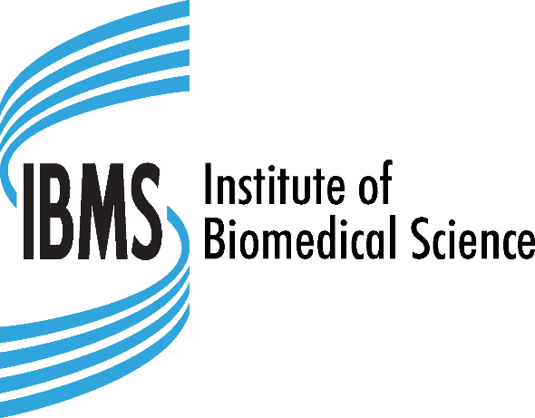

MEMBERSHIP

SUBSCRIPTION FEE REFUND POLICY

Introduction

The IBMS’ subscription year for Fellow, Member, Licentiate, Associate, Company and Retired members runs from January through to December.

For e-student members, membership lasts from the point in which you join in your first year, then becomes annual January – December until your graduation year.

Annual subscription renewal notices are sent to all members by email or post (except e-students) in December each year and advise:

* the amount of subscription due for the following year
* your chosen method of payment
* the date your payment is due / will be collected (if paying by direct debit).

For e-students, a reminder to renew your membership is sent by email in December. To view IBMS’ current fees, go to: <https://www.ibms.org/join/membership-fees/>

# Cancellation of subscription

If you wish to cancel your annual subscription, please send an email to [subs@ibms.org](mailto:subs@ibms.org) no later than 5 working days before the renewals due date or collection date (if paying by DD).

Or write to us at:

Membership

Institute of Biomedical Science

12 Coldbath Square

London EC1R 5HL

Requests to cancel a subscription **after payment has been received** are accepted but fees will be refunded below:

An admin fee of £30 is applied for all membership refunds except those who are fully paid and would like to change to the retired grade. The total amount to be refunded must total over £5.00 to be processed.

Refunds are then processed for the remaining complete months outstanding in the IBMS membership year, (January to December). For example, if you cancel in June, you will receive a refund for fees paid for July – December, minus the admin fee.

*For e.g. Licentiate resigning in June 2023 will be refunded as follows: Licentiate full fee is £109, so monthly fee is £109/12 = £9.08 Membership to be paid is 6 months at £9.08 per month = £54.48 Admin Fee = £30*

*Total paid £109 - £54.48 - £30 = £24.52 to be refunded*

*For e.g Fellow moving to retired in September* ***before*** *collection, paid by annual dd*

*Fellow for 8 months*

*£185/12 = £15.42*

*£15.42*8 = £123.36*

*Retired for 4 months*

*£43/12 = £3.58*

*£3.58*4 = £14.32*

*New retired fee = £123.36 + £14.32 = £137.68*

*Already paid = £180*

*£180 – £137.68 = £42.32 to be refunded*

# *Science Council fees

If a member is also paying for Science Council fees (RSciTech, RSci and CSci fees), a refund would be calculated as below:

Resigning membership and CSci

Paid by annual dd, cancelling in September **before** collection

Fellow for 8 months

£185/12 = £15.42

£15.42*8 = £123.36

CSci for 8 months

£54/12 = £4.50

£4.50*8 = £36

Amended fee

£123.36 + £36 = £159.36

Already paid

£180 + £54 = £234

**£234 –** £159.36 - £30 = £44.64 refund due

# Cooling off Period for New Members only

New members joining the IBMS for the first time have a 14-day cooling off period from the date that we collect your first payment during which you have the right to cancel your subscription and receive a full refund of the membership subscription paid, minus a £30 administration fee. You don’t need to give a reason to cancel your membership.

Should you wish to cancel your subscription within the 14-day period, send an email to [subs@ibms.org](mailto:subs@ibms.org)

Or write to us at:

Membership

Institute of Biomedical Science

12 Coldbath Square

London EC1R 5HL

Refunds will also be made to members affected by the following:

* where an Institute error has resulted in the Institute overcharging a member for their subscription. No administrative fee will be charged in these circumstances.
* where a member has contacted the Institute, in writing, to cancel or amend a membership payment within 5 working days before the collection date, but the Institute has been unable to process that request in time to prevent further payment being taken. No administrative fee will be charged in these circumstances.
* where an error by the Institute has resulted in the member incurring bank charges. The Institute will request proof that bank charges were triggered *solely* as a result of an IBMS request for payment from the member before the refund is actioned. A bank statement that merely displays the charge will not be acceptable circumstances. No administrative fee will be charged in these circumstances.
* where a member is transferring to a membership category with a lower annual cost having already paid in advance for a higher cost category (e.g., an annual DD payer transferring from Fellow to Retired part way through the membership year). In these circumstances, the member pays the full fee for the month (s) they were in the higher fee category, and the reduced rate for the remaining months(s). The £30 admin fee is not applicable in these circumstances.

# We won’t refund members who indicate that they could have retrospectively been in another membership category: for example, a Fellow who has been retired for two years.

**Members must inform us in writing of required changes to their circumstances at the time of those changes.**

**Methods of Refund**

If you paid by credit or debit card, partial and full refunds will be made directly to your credit or debit card. For payments made by any other methods, payment will be made by bank transfer. We’ll ask for your bank details first.

If you have any further questions about IBMS Subscription Refunds, then please contact us on + 44 (0) 20 7713 0214 or email [subs@ibms.org](mailto:subs@ibms.org)