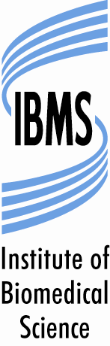

EXPERT PRACTICE and ADVANCED SPECIALIST DIPLOMAS

TRAINING LOGBOOK ORDER FORM

12 Coldbath Square, London EC1R 5HL, Tel: 020 7713 0214, Fax: 020 7837 9658, www.ibms.org; Email: examinations@ibms.org

Please complete all sections legibly. Illegible or incomplete application forms will be returned. The fee for the training logbook can be paid for by Purchase Order (which should accompany the form), cheque (made payable to the ‘IBMS’) or card (in which case you will be contacted for your card details once the form is received). Completed application forms can be submitted to by post, fax or via email (See Above). The current fee is published on the IBMS website. If you have any queries or require further information please contact the Head of Examinations at the above telephone number or email: examinations@ibms.org.

OFFICE USE ONLY | PAYMENT DETAILS | DATE LOGBOOK SENT

Discipline
DEP Histological Dissection DEP Immunocytochemistry

DEP Mohs Histological Procedures DEP Ultrastructural Pathology

ASD Specimen Dissection Breast Lower GI Urology

Your details

Surname Title (Mr/Mrs/Miss/Ms/Other)
Forename(s) IBMS membership number

Address for logbook to be sent

Address ………………………………………………………………………………………………………………..

Postcode ………………………………………………. Country ………… …………………………………

Tel number ……………………………………………. Mobile phone ……………………………………..

Email ……………………………………………………

Declaration

In providing IBMS with the information requested you are consenting to its use as indicated in the IBMS Privacy Notice. Further information can be found on the IBMS website at https://www.ibms.org/privacy/

Signature Date

